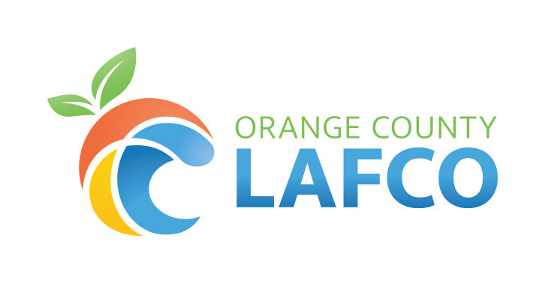

Local Agency Formation Commission
of Orange County

Commissioners’ Terms of Office
Updated: August 2024

Pursuant to Government Code Section 56334, the expiration date of the term of office of each member of the Commission is June 30th in the year in which the member's term expires.

Commissioners | Original Date Appointed to OC LAFCO | Current Term | Appointing Authority
Regular Members
Donald P. Wagner, Chair  County Member | 2019 | 2022–2026 | Independent Special District Selection Committee
Wendy Bucknum, Vice Chair City Member | 2015 | 2024–2028 | Board of Supervisors
Douglass Davert, Special District Member  Immediate Past Chair | 2018 | 2022–2026 | Commission
James Fisler, Special District Member | 2011 | 2024–2028 | City Selection Committee
Derek J. McGregor, Public Member | 2009 | 2022–2026 | Independent Special District Selection Committee
Bruce Whitaker, City Member* | 2023 | 2022–2026 | City Selection Committee
VACANT, County Member | 2022 | 2023–2027 | Board of Supervisors
Alternate Members
Carol Moore, City Member | 2023 | 2024–2028 | City Selection Committee
Kathryn Freshley, Special District Member | 2019 | 2022–2026 | Independent Special District Selection Committee
VACANT, County Member | 2023 | 2023–2027 | Board of Supervisors
Lou Penrose, Public Member | 2017 | 2021–2025 | Commission

*Appointed to complete the unexpired term ending in 2026

